PIZZA SALES SQL QUERIES
A. KPI’s
1. Retrieve the total number of orders placed:
SELECT count(order_id) AS Total_number FROM orders;
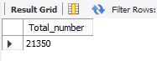
2. Calculate the total revenue generated from pizza sales:
SELECT
ROUND(SUM(quantity * price), 2) AS TOTAL_REVENUE
FROM
order_details AS od
JOIN
pizzas AS p ON od.pizza_id = p.pizza_id;
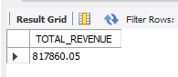
3. Identify the highest-priced pizza:
SELECT
pt.name, p.price
FROM
pizza_types AS pt
JOIN
pizzas AS p ON pt.pizza_type_id = p.pizza_type_id
ORDER BY p.price DESC
LIMIT 1;
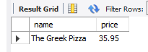

4. Identify the most common pizza size ordered:
SELECT
P.size, COUNT(OD.quantity) AS ORDER_COUNT
FROM
pizzas AS P
JOIN
order_details AS OD ON P.pizza_id = OD.pizza_id
GROUP BY P.size
ORDER BY ORDER_COUNT DESC
LIMIT 1;
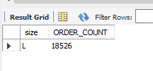

5. List the top 5 most ordered pizza types along with their quantities:
SELECT
pt.name, SUM(od.quantity) AS total_sum
FROM
pizza_types AS pt
JOIN
pizzas AS p ON pt.pizza_type_id = p.pizza_type_id
JOIN
order_details AS od ON od.pizza_id = p.pizza_id
GROUP BY pt.name
ORDER BY total_sum DESC
LIMIT 5;
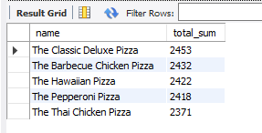

6. Join the necessary tables to find the total quantity of each pizza category ordered:
SELECT
pt.category, SUM(od.quantity) AS quantity
FROM
pizza_types AS pt
JOIN
pizzas AS p ON pt.pizza_type_id = p.pizza_type_id
JOIN
order_details AS od ON od.pizza_id = p.pizza_id
GROUP BY pt.category
ORDER BY quantity DESC;
Output:
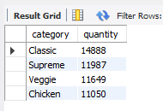

7. Determine the distribution of orders by hour of the day:
SELECT
HOUR(order_time) AS hour, COUNT(order_id) AS total_count
FROM
orders
GROUP BY HOUR(order_time);

Output
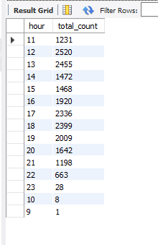
8. Join relevant tables to find the category-wise distribution of pizzas:
SELECT
category, COUNT(name)
FROM
pizza_types
GROUP BY category;
Output
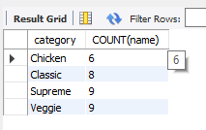
9. Group the orders by date and calculate the average number of pizzas ordered per day:
SELECT
ROUND(AVG(quantity), 0) AS avg_pizza_per_day
FROM
(SELECT
o.order_date, SUM(od.quantity) AS quantity
FROM
orders AS o
JOIN order_details AS od ON o.order_id = od.order_id
GROUP BY o.order_date) AS order_qty;
Output
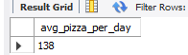
10. Determine the top 3 most ordered pizza types based on revenue:
SELECT
pt.name, ROUND(SUM(od.quantity * p.price),1) AS revenue
FROM
pizza_types AS pt
JOIN
pizzas AS p ON pt.pizza_type_id = p.pizza_type_id
JOIN
order_details AS od ON od.pizza_id = p.pizza_id
GROUP BY pt.name
ORDER BY revenue DESC
LIMIT 3;
Output
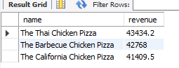
11. Calculate the percentage contribution of each pizza type to total revenue:
SELECT
pt.category,
ROUND(SUM(od.quantity * p.price) / (SELECT
SUM(od.quantity * p.price)
FROM
order_details od
JOIN
pizzas p ON p.pizza_id = od.pizza_id) * 100,
2) AS revenue
FROM
pizza_types pt
JOIN
pizzas p ON pt.pizza_type_id = p.pizza_type_id
JOIN
order_details od ON od.pizza_id = p.pizza_id
GROUP BY pt.category
ORDER BY revenue DESC;
Output
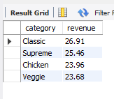
12. Analyze the cumulative revenue generated over time:
SELECT order_date, round(sum(revenue) over(order by order_date),2) as cum_revenue
from
(select orders.order_date, sum(order_details.quantity*pizzas.price) as revenue
from order_details join pizzas on order_details.pizza_id = pizzas.pizza_id
join orders
on orders.order_id = order_details.order_id
group by orders.order_date) as sales;
Output
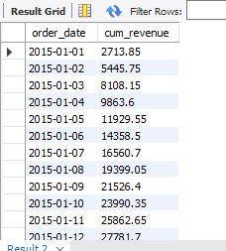

13. Determine the top 3 most ordered pizza types based on revenue for each pizza category.
select name, revenue from
(select category, name, revenue,
rank() over(partition by category order by revenue desc) as rn
from
( SELECT pizza_types.category, pizza_types.name ,
sum((order_details.quantity) * pizzas.price) as revenue from pizza_types
join pizzas
on pizza_types.pizza_type_id = pizzas.pizza_type_id
join order_details
on order_details.pizza_id = pizzas.pizza_id
group by pizza_types.category, pizza_types.name) as a ) as b
where rn <= 3;
Output
